

Project Report on

# Driver Alert System Using CAN Protocol

**Submitted by**

|  |  |
| --- | --- |
| **Hardik Kapoor** | **(240844230029)** |
| **Ummidi Manoj** | **(240844230090)** |
| **Shivani Lokhande** | **(240844230080)** |
| **Anjalita Kumari** | **(240844230007)** |

Under the guidance of

**Ms. Utkarsha Nikam**

**In partial fulfillment of the award of Post Graduate Diploma in Embedded Systems And Designs**

**(PG-DESD)**



**Sunbeam Institute of Information Technology, Pune (Maharashtra)**

**PG-DESD -2024**

# DECLARATION

We declare that this written submission represents our ideas in our own words and where others ideas or words have been included; we have adequately cited and referenced the original sources. We also declare that we have adhered to all principles of academic honesty and integrity and have not misrepresented or fabricated or falsified any idea/data/fact/source in our submission. We understand that any violation of the above will cause for disciplinary action by the Institute and can also evoke penal action from the sources which have thus not been properly cited or from whom proper permission has not been taken when needed**.**

Place: Pune Date:

|  |  |  |  |
| --- | --- | --- | --- |
| **Hardik Kapoor** | **Ummidi Manoj** | **Shivani Lokhande** | **Anjalita Kumari** |
| **(240844230029)** | **(240844230090)** | **(240844230080)** | **(240844230007)** |

# CERTIFICATE

This is to certify that the project report entitled **“Diver Alert Using CAN Protocol”,** submitted by **Hardik Kapoor** is the bona-fide work completed under our supervision and guidance in partial fulfillment for the award of Post Graduate Diploma in Embedded Systems And Designs (PG-DESD) of Sunbeam Institute of Information Technology, Pune (M.S.).

Place: Pune Date:

**Ms. Utkarsha Nikam Mr. Devendra Dhande**

Guide Course Coordinator

# CERTIFICATE

This is to certify that the project report entitled **“Diver Alert Using CAN Protocol”,** submitted by **Ummidi Manoj** is the bona-fide work completed under our supervision and guidance in partial fulfillment for the award of Post Graduate Diploma in Embedded Systems And Designs (PG-DESD) of Sunbeam Institute of Information Technology, Pune (M.S.).

Place: Pune Date:

**Ms. Utkarsha Nikam Mr. Devendra Dhande**

Guide Course Coordinator

# CERTIFICATE

This is to certify that the project report entitled **“Diver Alert Using CAN Protocol”,** submitted by **Shivani Lokhande** is the bona-fide work completed under our supervision and guidance in partial fulfillment for the award of Post Graduate Diploma in Embedded Systems And Designs (PG-DESD) of Sunbeam Institute of Information Technology, Pune (M.S.).

Place: Pune Date:

**Ms. Utkarsha Nikam Mr. Devendra Dhande**

Guide Course Coordinator

# CERTIFICATE

This is to certify that the project report entitled **“Diver Alert Using CAN Protocol”,** submitted by **Anjalita Kumari** is the bona-fide work completed under our supervision and guidance in partial fulfillment for the award of Post Graduate Diploma in Embedded Systems And Designs (PG-DESD) of Sunbeam Institute of Information Technology, Pune (M.S.).

Place: Pune Date:

**Ms. Utkarsha Nikam Mr. Devendra Dhande**

Guide Course Coordinator

# APPROVAL CERTIFICATE

This Project II report entitled **“Driver Alert System Using CAN Protocol”** by **Hardik Kapoor (240844230029)** is approved for Post Graduate Diploma in Embedded Systems (PG-DESD) of Sunbeam Institute of Information Technology, Pune (M.S.).

Place: Pune Date:

Examiner:

**(Signature)**

**(Name)**

# APPROVAL CERTIFICATE

This Project II report entitled **“Driver Alert System Using CAN Protocol”** by **Umiddi Manoj (240844230090)** is approved for Post Graduate Diploma in Embedded Systems (PG-DESD) of Sunbeam Institute of Information Technology, Pune (M.S.).

Place: Pune Date:

Examiner:

**(Signature)**

**(Name)**

# APPROVAL CERTIFICATE

This Project II report entitled **“Driver Alert System Using CAN Protocol”** by **Shivani Lokhande (240844230080)** is approved for Post Graduate Diploma in Embedded Systems (PG-DESD) of Sunbeam Institute of Information Technology, Pune (M.S.).

Place: Pune Date:

Examiner:

**(Signature)**

**(Name)**

# APPROVAL CERTIFICATE

This Project II report entitled **“Driver Alert System Using CAN Protocol” by Anjalita Kumari (240844230007)** is approved for Post Graduate Diploma in Embedded Systems (PG-DESD) of Sunbeam Institute of Information Technology, Pune (M.S.).

Place: Pune Date:

Examiner:

**(Signature)**

**(Name)**

# CONTENTS

|  |
| --- |
|  |
| **Declaration** |
| **Certificate** |
| **Approval Certificate** |
| **Abstract** |
| **1. Introduction** |
| **2. About the Project** |
| **3.Components Diagram** |
| **4. About Components** |
| **5.Block Diagram Of Project** |
| **6.Project Output** |
| **7. Future Scope** |
| **8.Conclusion** |

**ABSTRACT**

The CAN-Based Driver Alert System for Car Reversing with Ultrasonic and Temperature Sensors is designed to enhance vehicle safety and monitoring by integrating multiple sensors and real-time data communication. The system utilizes ultrasonic sensors to detect obstacles during vehicle reversing, ensuring accident prevention by providing immediate alerts to the driver. Additionally, an LM35 temperature sensor is incorporated to monitor environmental or engine temperature, enhancing vehicle safety by preventing overheating-related issues.

Sensor data is transmitted via theController Area Network (CAN) protocol, ensuring reliable and real- time communication between different vehicle modules. When an obstacle is detected within a predefined range, the system triggers an alert mechanism, including an LCD display and LED indicators, to notify the driver. The system also features IoT integration with ThingsBoard, allowing remote monitoring and real-time data visualization on the cloud.

This project demonstrates the efficient use of CAN communication for automotive safety, providing a cost-effective, scalable, and IoT-enabled solution for modern vehicles. By integrating both collision detection and temperature monitoring, the system enhances overall vehicle security and driver awareness.

1

# 1.INTRODUCTION

Road safety has always been a significant concern, especially with the increasing number of vehicles on the road. One of the most common causes of accidents occurs during vehicle reversing, where limited visibility can lead to collisions with obstacles, pedestrians, or other vehicles. Additionally, monitoring vehicle temperature is crucial to prevent overheating, which can lead to engine failure and safety hazards. To address these challenges, this project presents a CAN-Based Driver Alert System for Car Reversing with Ultrasonic and Temperature Sensors, which enhances vehicle safety by integrating collision detection, temperature monitoring, and cloud-based data transmission.

The system employs ultrasonic sensors to detect objects in the vehicle’s rear path while reversing. These sensors continuously measure the distance between the vehicle and nearby obstacles and send real-time data to a microcontroller. If an obstacle is detected within a predefined threshold, the system immediately alerts the driver through multiple indicators, including LED indicators, and an LCD display. This ensures that the driver is informed well in advance, allowing for quick response and accident prevention.

In addition to obstacle detection, the system incorporates an LM35 temperature sensor to monitor temperature variations. Overheating can lead to severe vehicle damage or safety risks, and continuous monitoring of temperature data allows the driver to take necessary precautions. The temperature readings are displayed on the LCD screen and can be further analyzed for preventive maintenance.

The Controller Area Network (CAN) protocol is used to ensure reliable and efficient communication between different vehicle modules. CAN is widely utilized in the automotive industry due to its ability to support real-time, error-resistant data exchange between electronic control units . The implementation of CAN in this system ensures robust and synchronized data transmission, enhancing system performance and reliability.

Furthermore, the system integrates IoT (Internet of Things) capabilities through ThingsBoard, enabling real-time data transmission to the cloud. By connecting the system to an IoT platform, sensor data can be remotely monitored, stored, and analyzed. This allows vehicle owners or fleet managers to access crucial information about vehicle conditions from anywhere, improving predictive maintenance and overall vehicle efficiency.

With the combination of collision prevention, temperature monitoring, real-time alerts, and cloud-based connectivity, this project offers a cost-effective, scalable, and intelligent safety solution for modern vehicles. By leveraging CAN communication and IoT technology, it ensures a highly reliable and efficient approach to vehicle safety, reducing accidents and enhancing driver awareness in challenging driving conditions.

# 2.About the Project

The CAN-Based Driver Alert System for Car Reversing with Ultrasonic and Temperature Sensors is designed to enhance vehicle safety by integrating real-time obstacle detection, temperature monitoring, and IoT-based remote data access. This project utilizes ultrasonic sensors to detect obstacles behind the vehicle during reversing and an LM35 temperature sensor to monitor temperature variations. The system is built using the Controller Area Network (CAN) protocol, which ensures efficient and reliable communication between different vehicle modules.

When the ultrasonic sensor detects an obstacle within a predefined range, the system immediately alerts the driver through multiple warning mechanisms, including a buzzer, LED indicators, and an LCD display. This allows the driver to react promptly and avoid potential collisions. Simultaneously, the LM35 temperature sensor continuously monitors temperature readings to help prevent overheating-related issues in the vehicle. The temperature data is also displayed on the LCD screen for real-time monitoring.

A key feature of this project is its IoT integration using ThingsBoard enables real-time data transmission to the cloud. Through IoT connectivity, sensor data such as obstacle distance and temperature readings can be accessed remotely, allowing vehicle owners or fleet managers to monitor vehicle safety conditions from anywhere. This enhances predictive maintenance and improves overall vehicle efficiency.

The use of the CAN protocol ensures that all system components communicate seamlessly, making the system highly reliable, efficient, and scalable. CAN is widely used in modern automobiles due to its robust error-handling capabilities, reduced wiring complexity, and high-speed communication, making it an ideal choice for this application.

By integrating collision prevention, temperature monitoring, and IoT-based data access, this project provides a comprehensive and cost-effective solution for vehicle safety. It enhances driver awareness, reduces accident risks, and improves vehicle performance, making it suitable for automotive applications, smart vehicle systems, and advanced driver assistance systems

.

# 3.Components Diagram

# 

# 4.About Components

# Stm32f407

# The **STM32F407** is a high-performance **ARM Cortex-M4** microcontroller from STMicroelectronics, designed for embedded applications requiring advanced processing capabilities. It features a **168 MHz CPU**, **1 MB Flash memory**, **192 KB RAM**, and a range of **peripherals**, including **USB OTG, CAN, I2C, SPI, UART, ADC, and DAC**. With its **DSP instructions, floating-point unit (FPU), and extensive GPIOs**, the STM32F407 is ideal for real-time applications like **motor control, industrial automation, IoT, and automotive systems**. Its **low power consumption, high-speed processing, and rich peripheral support** make it a widely used microcontroller for embedded system development.

# Transreceiver (MCP2511)

# The **MCP2515** is a stand-alone **Controller Area Network (CAN) controller** from Microchip Technology, designed to add **CAN communication** capabilities to microcontrollers that lack built-in CAN support. It interfaces with microcontrollers via the **buses to transmit the differential signals.** Its **low power consumption, ease of integration, and robust error-handling capabilities** make it a popular choice for embedded systems requiring CAN communication.

# HD44780 LCD

# The **HD44780** is a widely used **LCD controller** developed by Hitachi, designed for driving **alphanumeric LCD displays** with configurations like **16x2, 20x4, and more**. It operates in both **4-bit and 8-bit modes**, interfacing easily with microcontrollers using **parallel communication**. The controller includes an internal **character generator ROM (CGROM)** for predefined fonts and a **character generator RAM (CGRAM)** for custom characters. It supports **cursor control, blinking text, and scrolling**, making it ideal for **embedded systems, industrial displays, and consumer electronics**. Its **simplicity, compatibility, and reliability** make the HD44780 a standard choice for text-based LCD modules.

# MQ2

# The **MQ2** is a widely used **gas sensor** designed for detecting **flammable and combustible gases** such as **LPG, propane, methane, hydrogen, alcohol, and smoke**. It operates by measuring changes in **resistance** due to gas concentration and provides both **analog and digital outputs** for easy interfacing with microcontrollers. The sensor has **fast response time, high sensitivity, and a simple calibration process**, making it ideal for **gas leak detection, fire safety systems, and air quality monitoring**. Its **low cost, ease of use, and wide detection range** make the MQ2 a popular choice for embedded and IoT-based safety applications.

# LM35

# The **LM35** is a precision **temperature sensor** that provides an **analog output voltage** proportional to temperature in **degrees Celsius**. It offers **high accuracy (±0.5°C typical at 25°C)** and a **linear output of 10mV per °C**, eliminating the need for external calibration. Operating over a wide temperature range (**-55°C to 150°C**), the LM35 is ideal for **industrial, medical, and environmental monitoring applications**. With its **low power consumption, fast response time, and easy interfacing with microcontrollers**, the LM35 is a popular choice for **temperature sensing in embedded systems and IoT applications**

# **Ultrasonic Sensor (HC- SR204)**

# **The HC-SR04 is a widely used ultrasonic distance sensor designed for non-contact distance measurement in embedded systems. It operates by transmitting ultrasonic waves (40 kHz) and measuring the time taken for the echo to return, allowing accurate distance calculation within a range of 2 cm to 400 cm with an accuracy of ±3 mm. The sensor provides a digital output and is easily interfaced with microcontrollers using trigger and echo pins. With its low cost, high precision, and simple integration, the HC-SR04 is ideal for robotics, obstacle detection, automation, and IoT applications.**

# 

**5.Block Diagram**

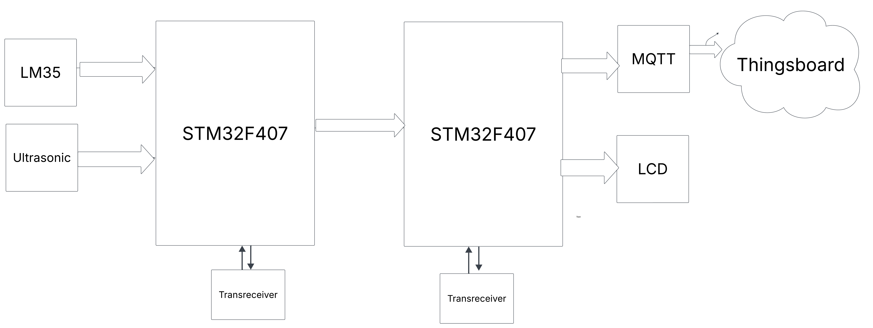

**6.Project Output**

The CAN-Based Driver Alert System for Car Reversing with Ultrasonic and Temperature Sensors provides a real-time safety mechanism that alerts drivers about potential obstacles and monitors temperature conditions. The system's output is based on data received from ultrasonic sensors and an LM35 temperature sensor, processed and communicated through the Controller Area Network (CAN) protocol, ensuring seamless and reliable operation.

When the vehicle is in reverse mode, the ultrasonic sensor continuously measures the distance between the vehicle and any obstacle in its path. If an obstacle is detected within a predefined range (e.g., less than 50 cm), the system triggers alerts through multiple indicators, providing a progressive warning system to the driver. Simultaneously, LED indicators light up, and an LCD screen displays the exact distance of the obstacle, ensuring the driver has clear, real-time feedback on the situation.

In addition to obstacle detection, the LM35 temperature sensor continuously monitors the vehicle’s ambient or engine temperature. The temperature data is displayed on the LCD screen, allowing the driver to take precautionary measures if the temperature exceeds a critical threshold. If overheating is detected, an alert mechanism can be triggered to notify the driver to check the vehicle's cooling system.

The CAN protocol plays a crucial role in ensuring that all system components communicate efficiently. The sensor data is transmitted over the CAN bus, enabling quick and reliable data exchange between different modules. This minimizes wiring complexity and improves system robustness, making the implementation highly suitable for automotive applications.

Additionally, the system features IoT integration using ThingsBoard, allowing sensor data (such as obstacle distance and temperature readings) to be transmitted to the cloud for remote monitoring. This enables users to access real-time vehicle status through an online dashboard, making it particularly useful for fleet management, vehicle diagnostics, and predictive maintenance. The cloud storage capability ensures that historical data can be analyzed to improve vehicle safety and performance over time.

Overall, the project output successfully enhances driver awareness and vehicle safety by combining collision detection, temperature monitoring, real-time alerts, and IoT-based remote monitoring. This cost-effective and scalable system not only prevents accidents but also contributes to efficient vehicle management, making it a valuable addition to modern automotive technology.

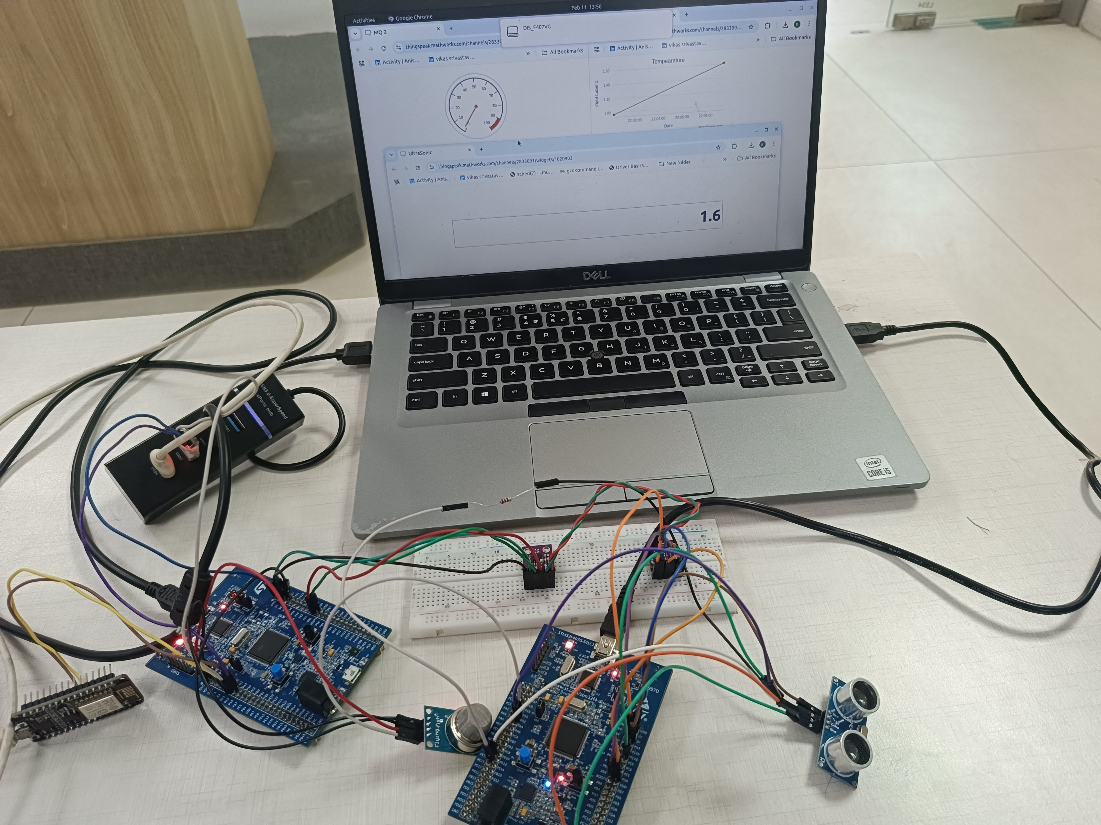

**7.Future Scope**

1. Integration with Advanced Driver Assistance Systems (ADAS) – The system can be expanded to integrate with AI-based object recognition and camera modules to improve accuracy and provide a more advanced collision avoidance mechanism.
2. Wireless Communication for Vehicle-to-Vehicle (V2V) and Vehicle-to-Infrastructure (V2I) Communication – The system can be enhanced with wireless communication protocols such as LoRa, Zigbee, or 5G, allowing vehicles to share real-time safety data with nearby vehicles and traffic infrastructure.
3. Enhanced IoT Features with AI and Machine Learning – By implementing AI and ML algorithms, the system can analyze past sensor data to predict vehicle behavior, improve obstacle detection accuracy, and suggest preventive maintenance schedules based on temperature variations.
4. Mobile Application for Remote Monitoring – A dedicated mobile app can be developed to allow real-time vehicle tracking, alert notifications, and historical data analysis, improving convenience for fleet management and personal vehicle monitoring.
5. Extended Sensor Support for More Safety Features – Additional sensors like gyroscopes, accelerometers, and infrared sensors can be incorporated to detect vehicle tilting, sudden braking, or pedestrian movement, making the system more comprehensive.

**8. Conclusion**

The CAN-Based Driver Alert System for Car Reversing with Ultrasonic and Temperature Sensors is an effective and intelligent safety solution designed to enhance vehicle security and driver awareness. By integrating ultrasonic sensors for obstacle detection, an LM35 sensor for temperature monitoring, and IoT connectivity for remote data access, the system provides real-time alerts to prevent accidents and overheating issues. The use of the Controller Area Network (CAN) protocol ensures efficient, reliable, and high-speed communication between system components, making it well-suited for modern automotive applications. Additionally, the IoT-based cloud integration with ThingsBoard allows remote monitoring, enabling predictive maintenance and improved vehicle diagnostics. With its cost-effective, scalable, and robust design, this project serves as a practical and innovative approach to enhancing road safety and vehicle performance, making it ideal for automotive and embedded system applications**.**